**ASSIGNMENT 4**

|  |  |
| --- | --- |
| **Name** | Thanya.S |
| **Team ID** | PNT2022TMID34205 |
| **Project Name** | IOT Based Smart Crop Protection System |

Write code and connections in wokwi for ultrasonic sensor.

Whenever distance is less than 100 cms send "alert" to ibm cloud and display in device recent events.

Upload document with wokwi share link and images of ibmcloud **CODE:**

|  |
| --- |
| #include <WiFi.h>  #include <PubSubClient.h>WiFiClientwifiClient;  #defineORG "nhpwjc"  #defineDEVICE_TYPE "NodeMCU"  #defineDEVICE_ID "USE YOUR ID"  #defineTOKEN "USE YOUR TOKEN"  #definespeed 0.034  char server[] = ORG  ".messaging.internetofthings.ibmcloud.com"; char publishTopic[] = "iot-2/evt/Data/fmt/json";char topic[] = "iot-2/cmd/home/fmt/String"; char authMethod[] = "use-tokenauth";char token[] = TOKEN;  char clientId[] = "d:" ORG ":" DEVICE_TYPE ":" DEVICE_ID;PubSubClient client(server, 1883, wifiClient); void publishData();  const int trigpin=5;  const int echopin=18;  String command;  String data="";long  duration; float dist;  void  setup()  {  **Serial**.begin(115200); pinMode(trigpin, OUTPUT); |

|  |
| --- |
| pinMode(echopin, INPUT); wifiConnect(); mqttConnect();  }void loop() {publishData(); delay(500);  if (!client.loop()) { mqttConnect();}}  void wifiConnect() {  **Serial**.print("Connecting to "); **Serial**.print("Wifi");  WiFi.begin("Wokwi-GUEST", "", 6);while (WiFi.status() !=  WL_CONNECTED) { delay(500);  **Serial**.print(".");}  **Serial**.print("WiFi connected, IP address: "); **Serial**.println(WiFi.localIP());  }  void mqttConnect() {if  (!client.connected()) {  **Serial**.print("Reconnecting MQTT client to "); **Serial**.println(server); while (!client.connect(clientId, authMethod, token)) {**Serial**.print("."); delay(500);  }initManagedDevice();**Serial**.println();}}  void initManagedDevice() {if  (client.subscribe(topic)) {  // Serial.println(client.subscribe(topic));**Serial**.println("subscribe to cmd OK");  } else {  **Serial**.println("subscribe to cmd FAILED");}}void publishData()  {digitalWrite(trigpin,LOW); digitalWrite(trigpin,HIGH); |
| delayMicroseconds(10); digitalWrite(trigpin,LOW); duration=pulseIn(echopin,HIGH); dist=duration*speed/2; if(dist<100){  String payload = "{\"Alert distance\":"; payload += dist;payload+= "}";**Serial**.print("\n");  **Serial**.print("Sending payload: "); **Serial**.println(payload);  if (client.publish(publishTopic, (char*) payload.c_str())) {**Serial**.println("Publish OK");  } else {  **Serial**.println("Publish FAILED");}  }  } |

**CONNECTIONS:**

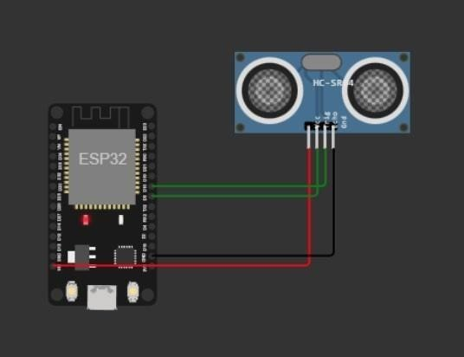

**OUTPUT:**

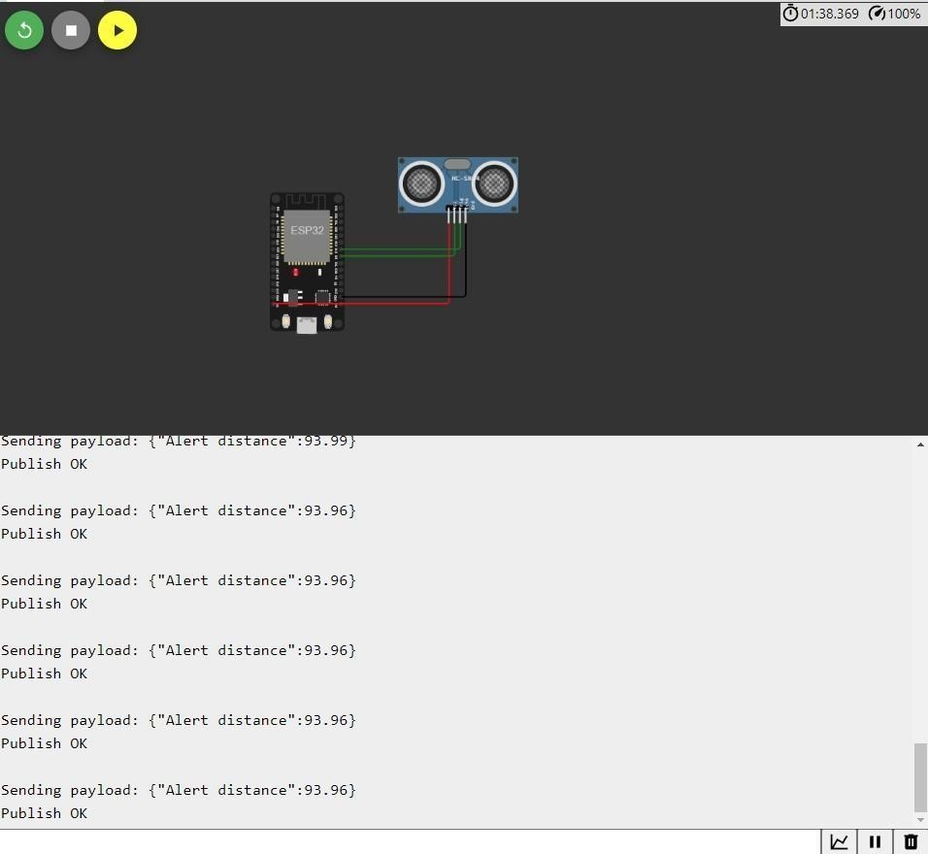

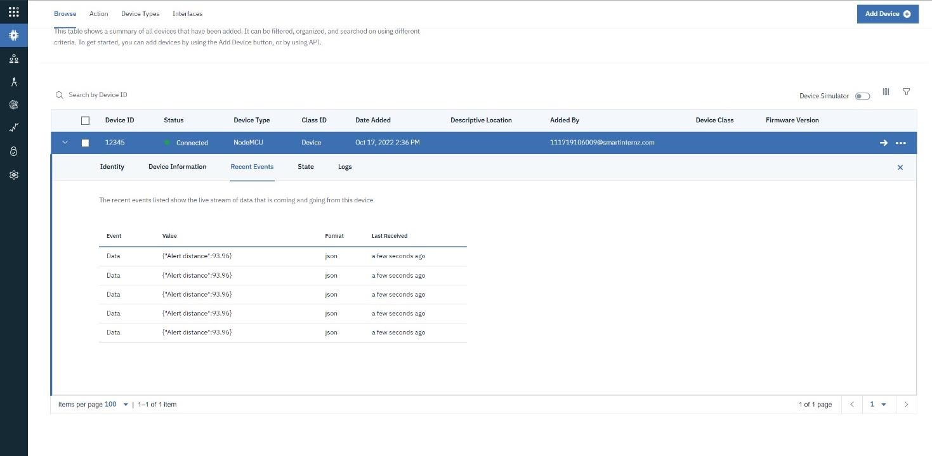

**WOKWI LINK -**

[New ESP32 Project - Wokwi Simulator](https://wokwi.com/projects/new/esp32)